E-Commerce

In this application I have used  
Built a Basic Ecommerce Website named Online Shopee which contains the basic operations like Login, Registering, View Products based on their choice add to cart etc..

by using the concepts

FRONT-END :

HTML

CSS

JavaScript for Validation

BACK-END :

JDBC for Database Connection

JSP for request processing

Oracle Database

SERVER USED :

Apache Tomcat Server

At first you need to get all your credentials by registering here itself an then

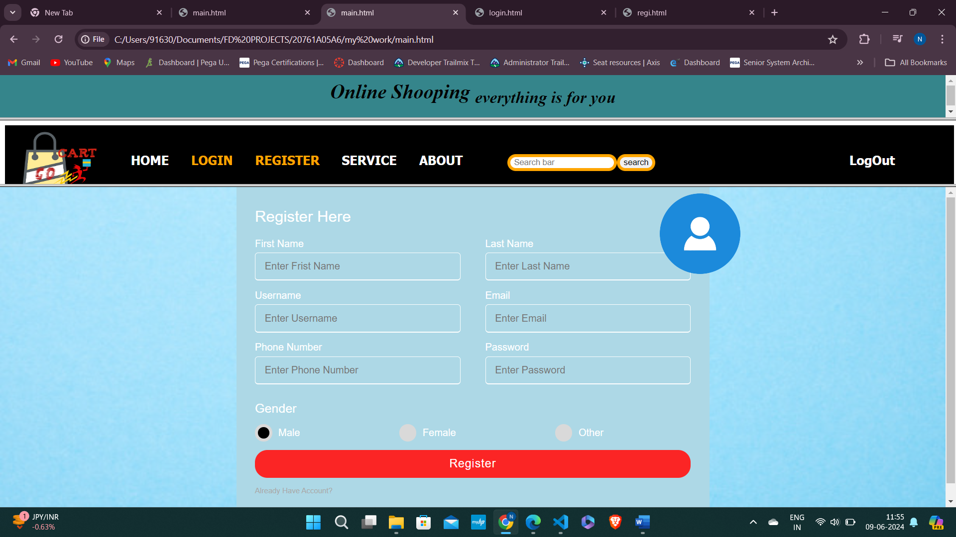

In this page you can login with your credentials

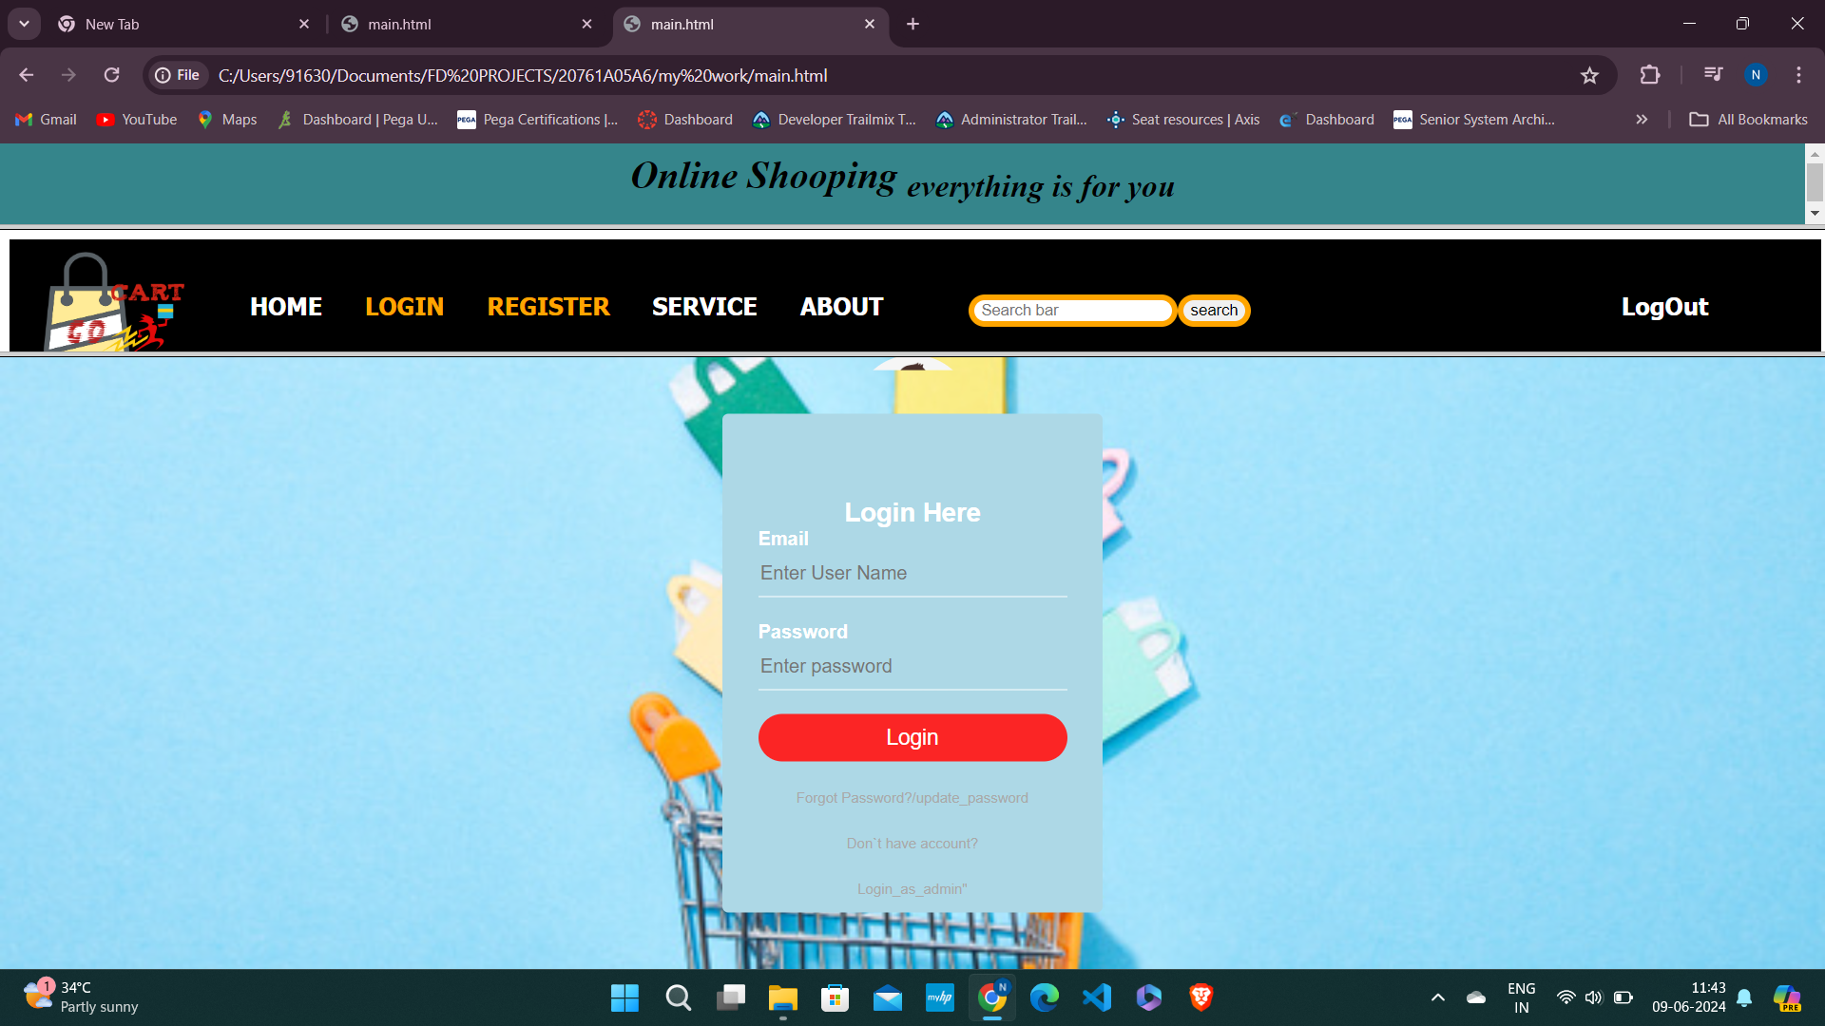

And then you can view all the Products overview category then in every category you can view the similar items mentioned below

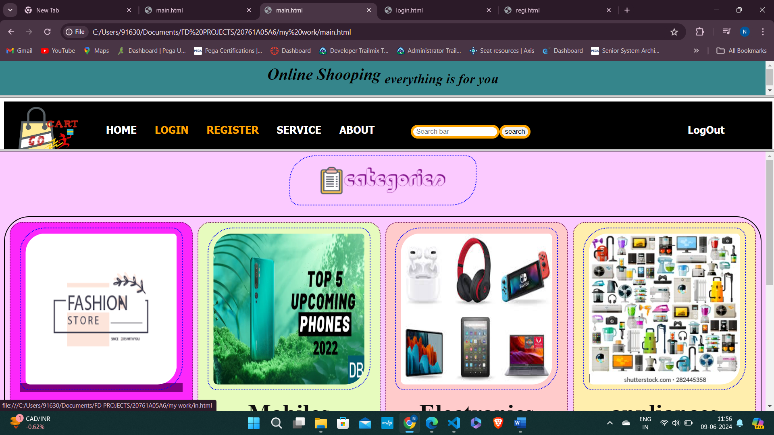

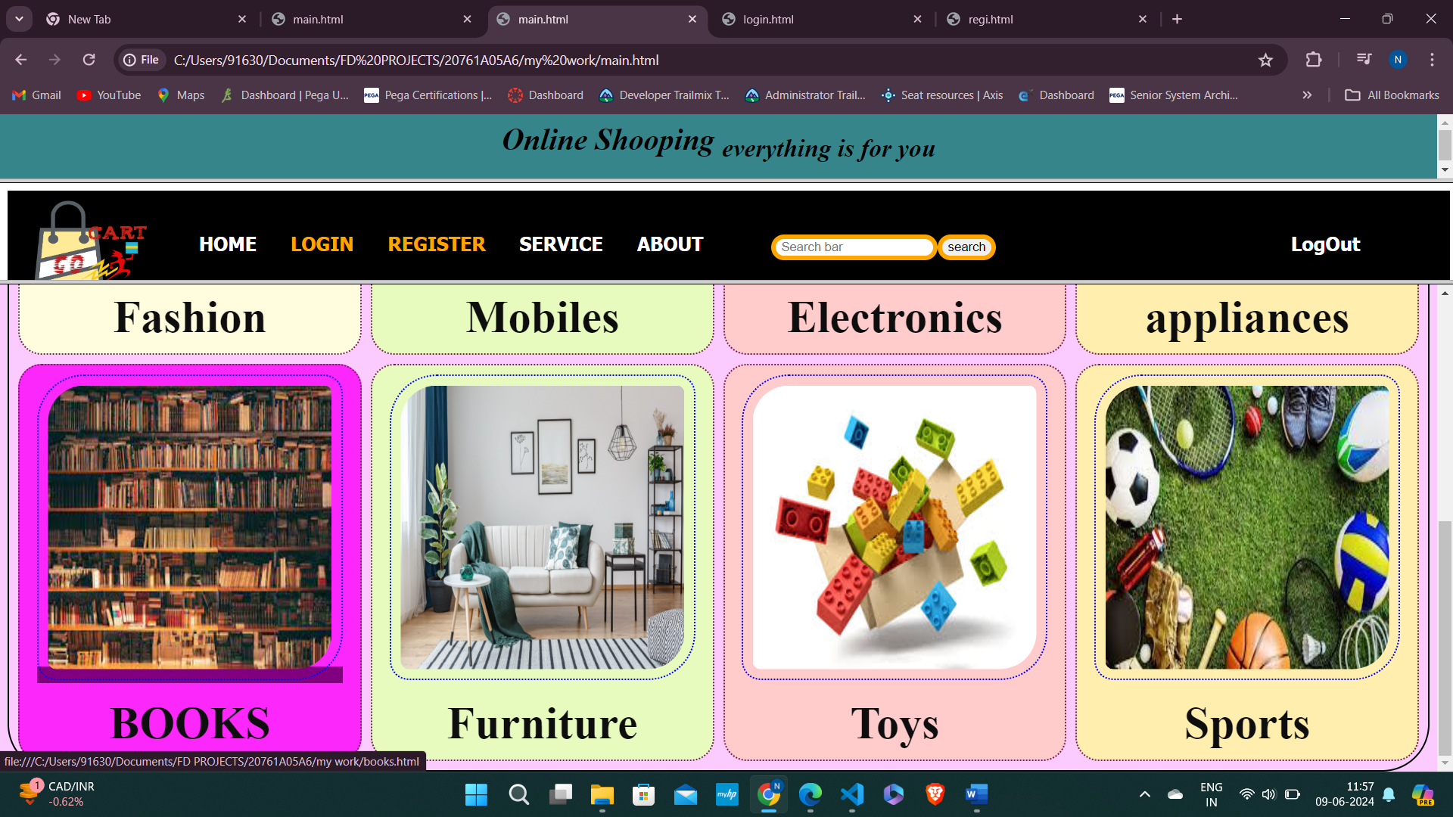

Here is the list of similar items for Fashion category

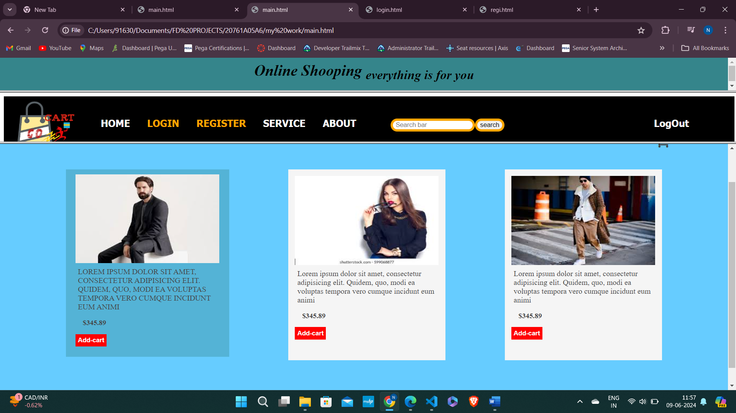

Here is the sample social media links for the website

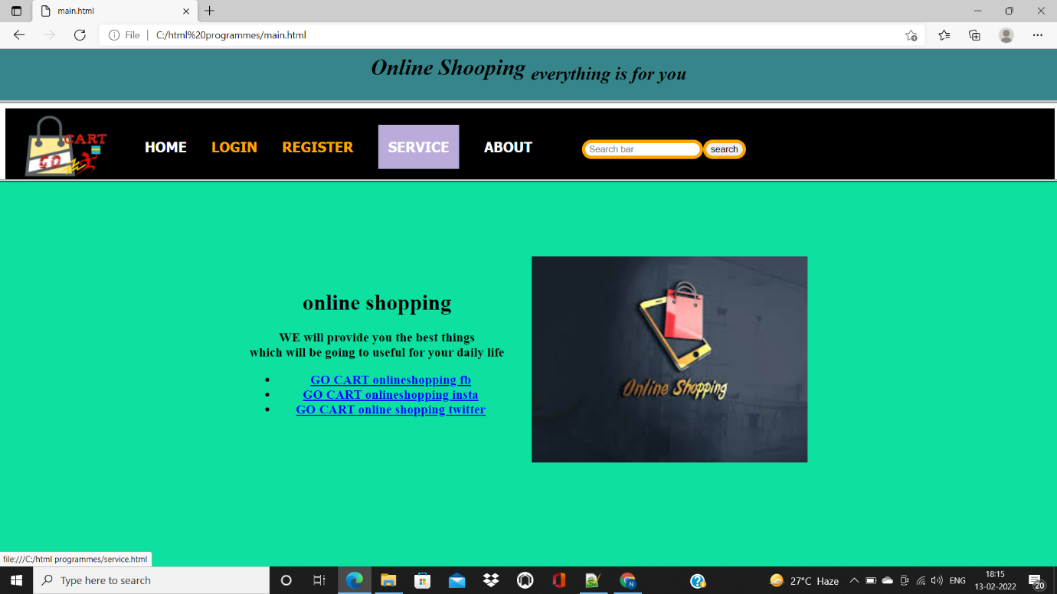

Here is the my profile where you can find my information

